**KNIGHTON HEATH GOLF CLUB**

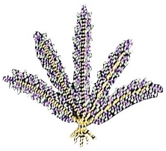

**MENS SENIOR SECTION**

**Annual General Meeting 2021**

Monday 20th September 2021

Nominations

***FOR THE OFFICER POSITION OF SENIORS CAPTAIN***

*Nominated: Richard Pearce*

***FOR THE OFFICER POSITION OF SENIORS VICE CAPTAIN***

*Nominated: Derek Haines*

***FOR THE OFFICER POSITION OF COMMITTEE MEMBER***

*Nominated: David Warburton*

*Nominated: Richard Collis*

*Nominated: Brian Saunders*

*Nominated: Graham Paine*